# Acceptance Criteria Testing

## Story ID 11

User Story: As a customer I want to be able to get a price estimate before booking a delivery so that I know how much the shipping will cost and I can plan for it.

* After entering the pickup location, location to deliver, size and weight of the package I can see an estimate of the shipping cost.
* I can get the cost if I want to add insurance or other extras to the delivery (such as same day delivery etc).

After entering pickup location, location to deliver, size and weight of the package I can see an estimate of the shipping cost.

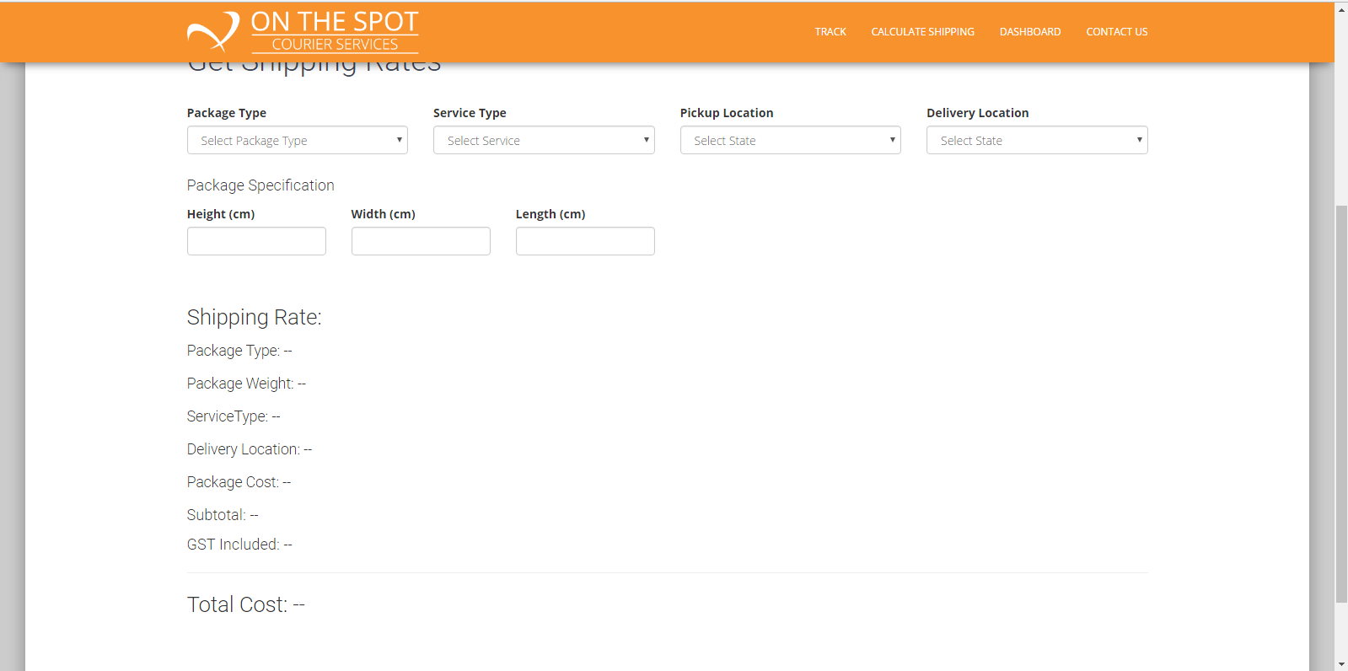

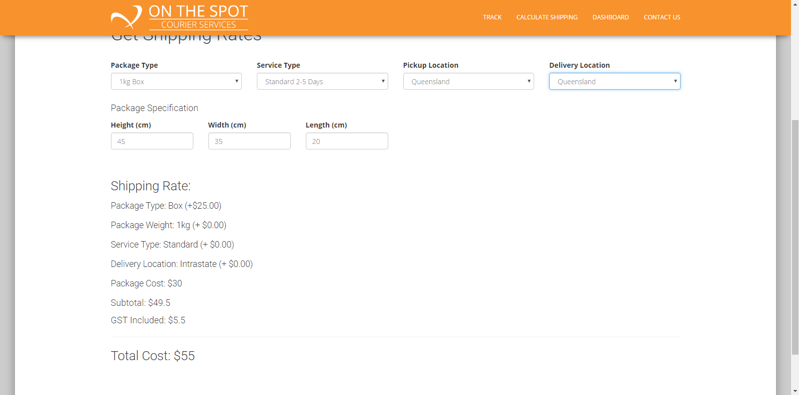

I can get the cost if I want to add insurance or other extras to the delivery (such as same day delivery etc).



NOT IMPLEMENTED → INSURANCE AND OTHER EXTRAS OTHER THAN DELIVERY SERVICE TYPE

During development the team decided it’d be simply and easier if insurance was added into the base price. Additionally other extras did not seem to hold much importance. Lastly when selecting the satchel options no cost is displayed. This was an oversight found during testing and will be fixed during the next sprint.